**App Launch Plan for StockPro+**

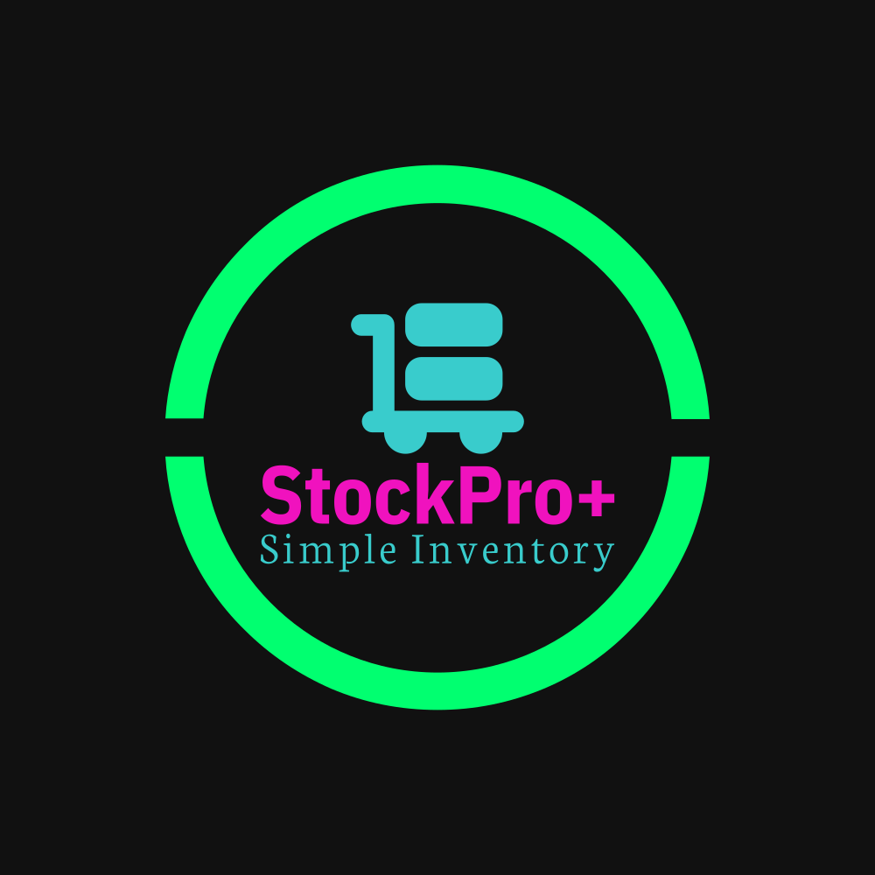

By: Branden Langhals

CS-360 Southern New Hampshire University

The StockPro+ Inventory Management App is a powerful tool designed to help its users efficiently manage their inventory. It is built on Android Pie (9.0) API 28, ensuring compatibility with a significant number of Android devices. This comprehensive app launch plan outlines the necessary components and considerations to successfully bring the app to the market.

1. App Description and Icon:

The app's description will highlight its key features, including inventory tracking, stock management, barcode scanning, and reporting capabilities. It will emphasize the app's user-friendly interface, robust functionality, and its ability to streamline inventory operations for businesses of all sizes. The description will also highlight compatibility with Android Pie, ensuring optimal performance on devices running this version.

As seen on page one of this document the icon is sleek, modern, and visually appealing to attract potential users browsing the app store. The bright colors match the easy to ready UI that is contained within the app itself.

2. Android Version Compatibility:

The StockPro+ Inventory Management App is designed to run seamlessly on devices with Android Pie (9.0) and higher versions. By targeting Android Pie as the minimum supported version, the app can reach a significant portion of the Android user base or as stated when creating the application using Android Studio about 84.1% of Android devices. The app's development process ensures compatibility with the specific components and considerations introduced in Android Pie, providing a smooth user experience on devices running this version.

3. App Permissions:

To ensure user privacy and data security, the app will request only the necessary permissions for its core functionality. These permissions may include:

- SMS Messaging: To report back to the user when an Inventory Item’s quantity has dropped below the value of 2.

- Camera: Required for barcode scanning and capturing product images for inventory management purposes.

- Storage: Necessary to save and access inventory data, reports, and user preferences.

- Internet: Essential for synchronizing inventory data across multiple devices, accessing online databases, and performing real-time updates.

- Network State: To determine the availability of network connectivity and provide appropriate feedback to the user.

4. Monetization Strategy:

The StockPro+ Inventory Management App will be offered as a premium subscription-based service. The monetization strategy will focus on providing an ad-free experience and access to exclusive features for a flat monthly fee of $4.99.

- Ad-Free Experience: The app will not display any advertisements, ensuring a distraction-free, clean user interface. This approach allows its users to focus on their inventory management tasks without interruptions, also while keeping a clean UI.

- Subscription Model: Users will have the option to subscribe to the StockPro+ premium plan, granting them access to advanced features and enhanced functionalities. The monthly subscription fee of $4.99 will provide ongoing access to premium features, priority support, and future updates.

- Value Proposition: The premium features may include advanced reporting and analytics, integration with third-party platforms, inventory forecasting, and customizable notifications. These features will provide businesses with additional insights and efficiency in managing their inventory as the user’s needs change.